**4.(Inverted half Pyramid )**

**Exercise**

* **Print the pattern using for loop**



**Approach:**

**So here we did like this**

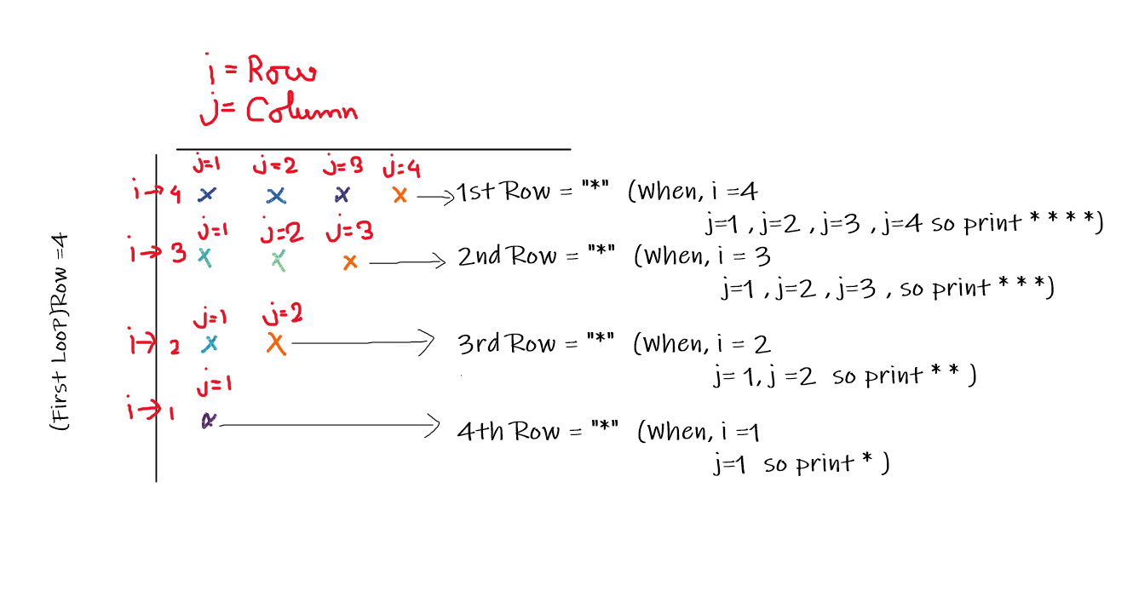

**Solution 👇**

**Java :**

**public class code_xam {**

**public static void main(String[] args) {**

**for (int i = 4 ; i >= 1; i--) {**

**for (int j = 1; j <= i; j++) {**

**System.out.print("*");**

**}**

**System.out.println();**

**}**

**}**

**}**

**output:**

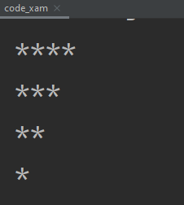

**Python :**

**for i in range(4, 0, -1):**

**for j in range(i + 1, 1, -1):**

**print("* ", end="")**

**print(" ")**

**output:**

